Useful Note:

* A *property* is simply a variable defined on a function

2 Interrelated concepts with prototype in JavaScript

1. Every JavaScript function has a prototype property
   * Prototype property is empty by default
   * You attach properties and methods on this prototype property when you want to implement inheritance
   * This property is not enumerable/callable but Firefox and most versions of Safari and Chrome have a “__proto__” pseudo property that allows you to access an object’s prototype property.
   * Prototype property is used primarily for INHERITANCE.

Example code:

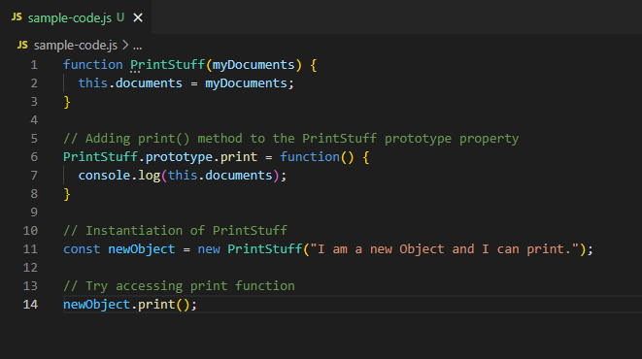



1. Prototype Attribute
   * Characteristic of the object
     + Tells us the object’s parent
   * Points to the object’s “parent” where the object inherited its properties/methods from
   * Normally referred to as “prototype object”
   * Set automatically when you create a new object

Example Code



* + newObjects prototype is PrintStuff.prototype

All objects have attributes just like object properties have attributes. Attributes of objects include:

* + Prototype
  + Class
  + Extensible

__proto__

* Contains an object’s prototype object (the parent object it inherited its methods and properties from)